SIGNAL & SYSTEMS LAB 3

Arjun Mehta

K036

B. Tech Cybersecurity

Sem3

05-08-2024

clc;

clear all;

close all;

A=5;

f=3;

t=[0:0.001:2];

x1=A\*sin(2\*pi\*f\*t);

subplot(4,4,1)

plot(t,x1)

xlabel('Time')

ylabel('Amplitude')

title('Sinusoidal Signal I')

xe=(x1+(A\*sin(2\*pi\*f\*(-t))))/2;

subplot(4,4,2)

plot(t,xe)

xlabel('Time')

ylabel('Amplitude')

title('The Even part of this signal')

xo=(x1-(A\*sin(2\*pi\*f\*(-t))))/2;

subplot(4,4,3)

plot(t,xo)

xlabel('Time')

ylabel('Amplitude')

title('The Odd part of this signal')

xnet=xo+xe;

subplot(4,4,4)

plot(t,xnet)

xlabel('Time')

ylabel('Amplitude')

title('Net signal obtained')

t=[0:0.001:2];

x2=A\*cos(2\*pi\*f\*t);

subplot(4,4,5)

plot(t,x2)

xlabel('Time')

ylabel('Amplitude')

title('Cosine I')

xce=(x2+(A\*cos(2\*pi\*f\*(-t))))/2;

subplot(4,4,6)

plot(t,xce)

xlabel('Time')

ylabel('Amplitude')

title('Even part of this signal')

xco=(x2-(A\*cos(2\*pi\*f\*(-t))))/2;

subplot(4,4,7)

plot(t,xco)

xlabel('Time')

ylabel('Amplitude')

title('Odd part of this signal')

xnet=xco+xce;

subplot(4,4,8)

plot(t,xnet)

xlabel('Time')

ylabel('Amplitude')

title('Net signal obtained')

A=5;

t=[0:0.001:2];

x1=A\*sin(2\*pi\*3\*t);

x2=A\*cos(2\*pi\*5\*t);

x3=x1+x2;

subplot(4,4,9)

plot(t,x3);

xlabel('Time')

ylabel('Amplitude')

title(' sin+cos signal obtained')

x4=-x3 %x3(t)==-x3(t)

xev=(x3+x4)/2

subplot(4,4,10)

plot(t,xev)

xlabel('Time')

ylabel('Amplitude')

title('Even component')

xod=(x3-x4)/2

subplot(4,4,11)

plot(t,xod)

xlabel('Time')

ylabel('Amplitude')

title('Odd component')

x5=xev+xod;

subplot(4,4,12)

plot(t,x5)

xlabel('Time')

ylabel('Amplitude')

title('Net Signal obtained')

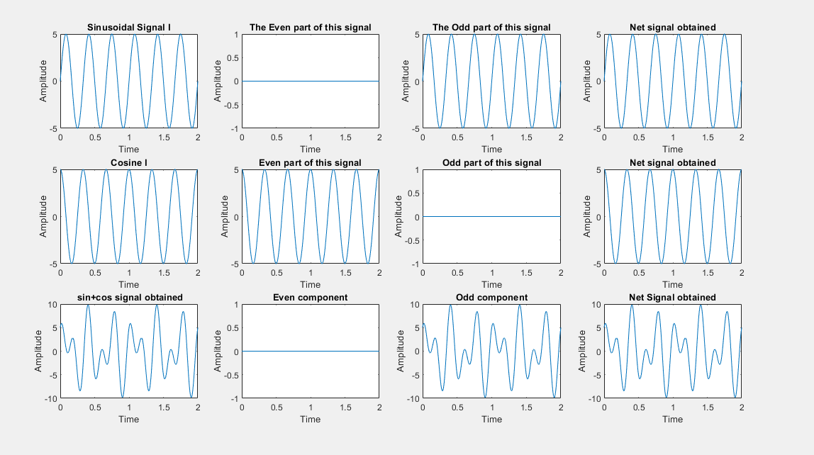

clc;

clear all;

close all;

n=[-3:1:3]

z=[zeros(1,3),1,2,3,4]

subplot(4,4,1)

stem(n,z)

title('Discrete Signal')

z1=[4,3,2,1,0,0,0]

subplot(4,4,2)

stem(n,z1)

title('Discrete Signal')

ze=(z+z1)/2;

subplot(4,4,3)

stem(n,ze)

title('Even Component')

zo=(z-z1)/2;

subplot(4,4,4)

stem(n,zo)

title('Odd Component')

z5=zo+ze;

subplot(4,4,5)

stem(n,z5)

title('Reconstructed Signal')

